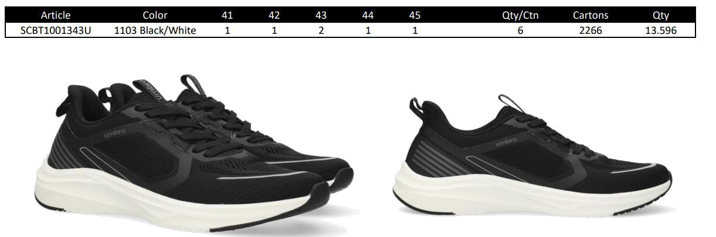

RRP > 59,95€
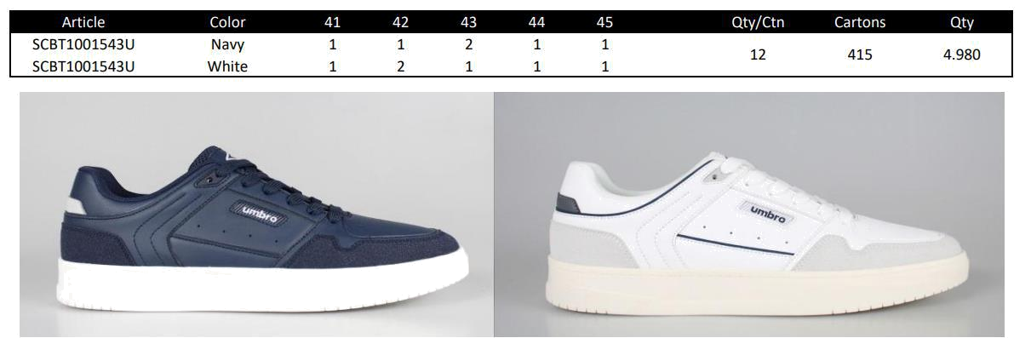

RRP > 59,95€
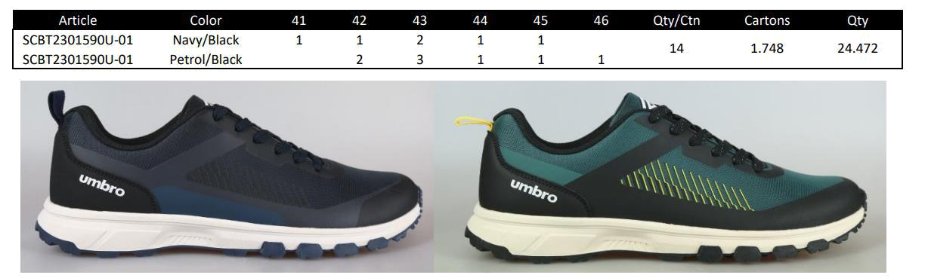

RRP > 69,95€

